IT24102390

Probability and statistics

Lab sheet 08

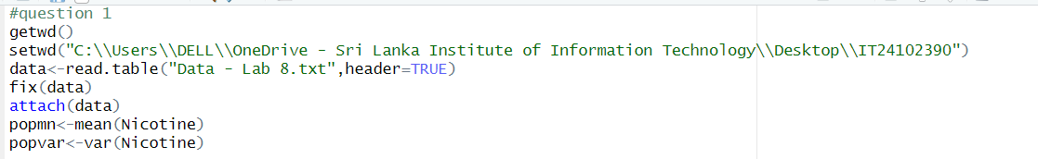

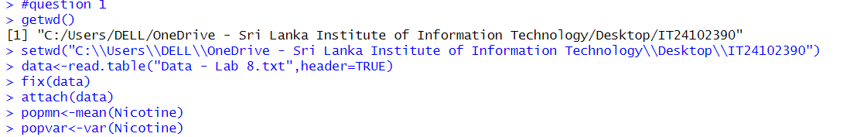

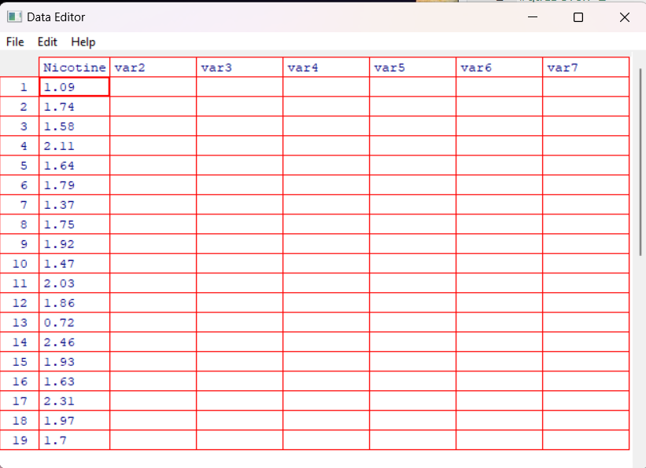

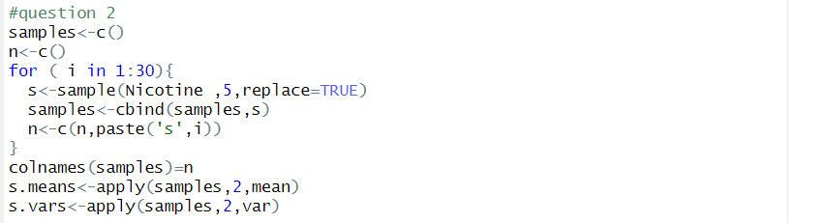

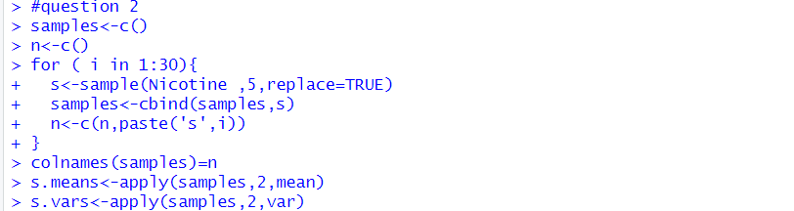

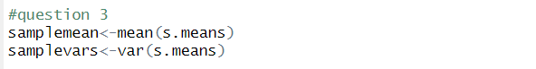

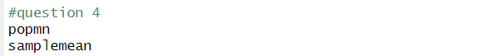

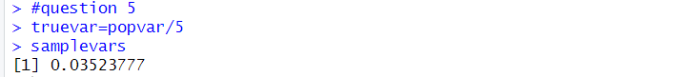

Exercise



